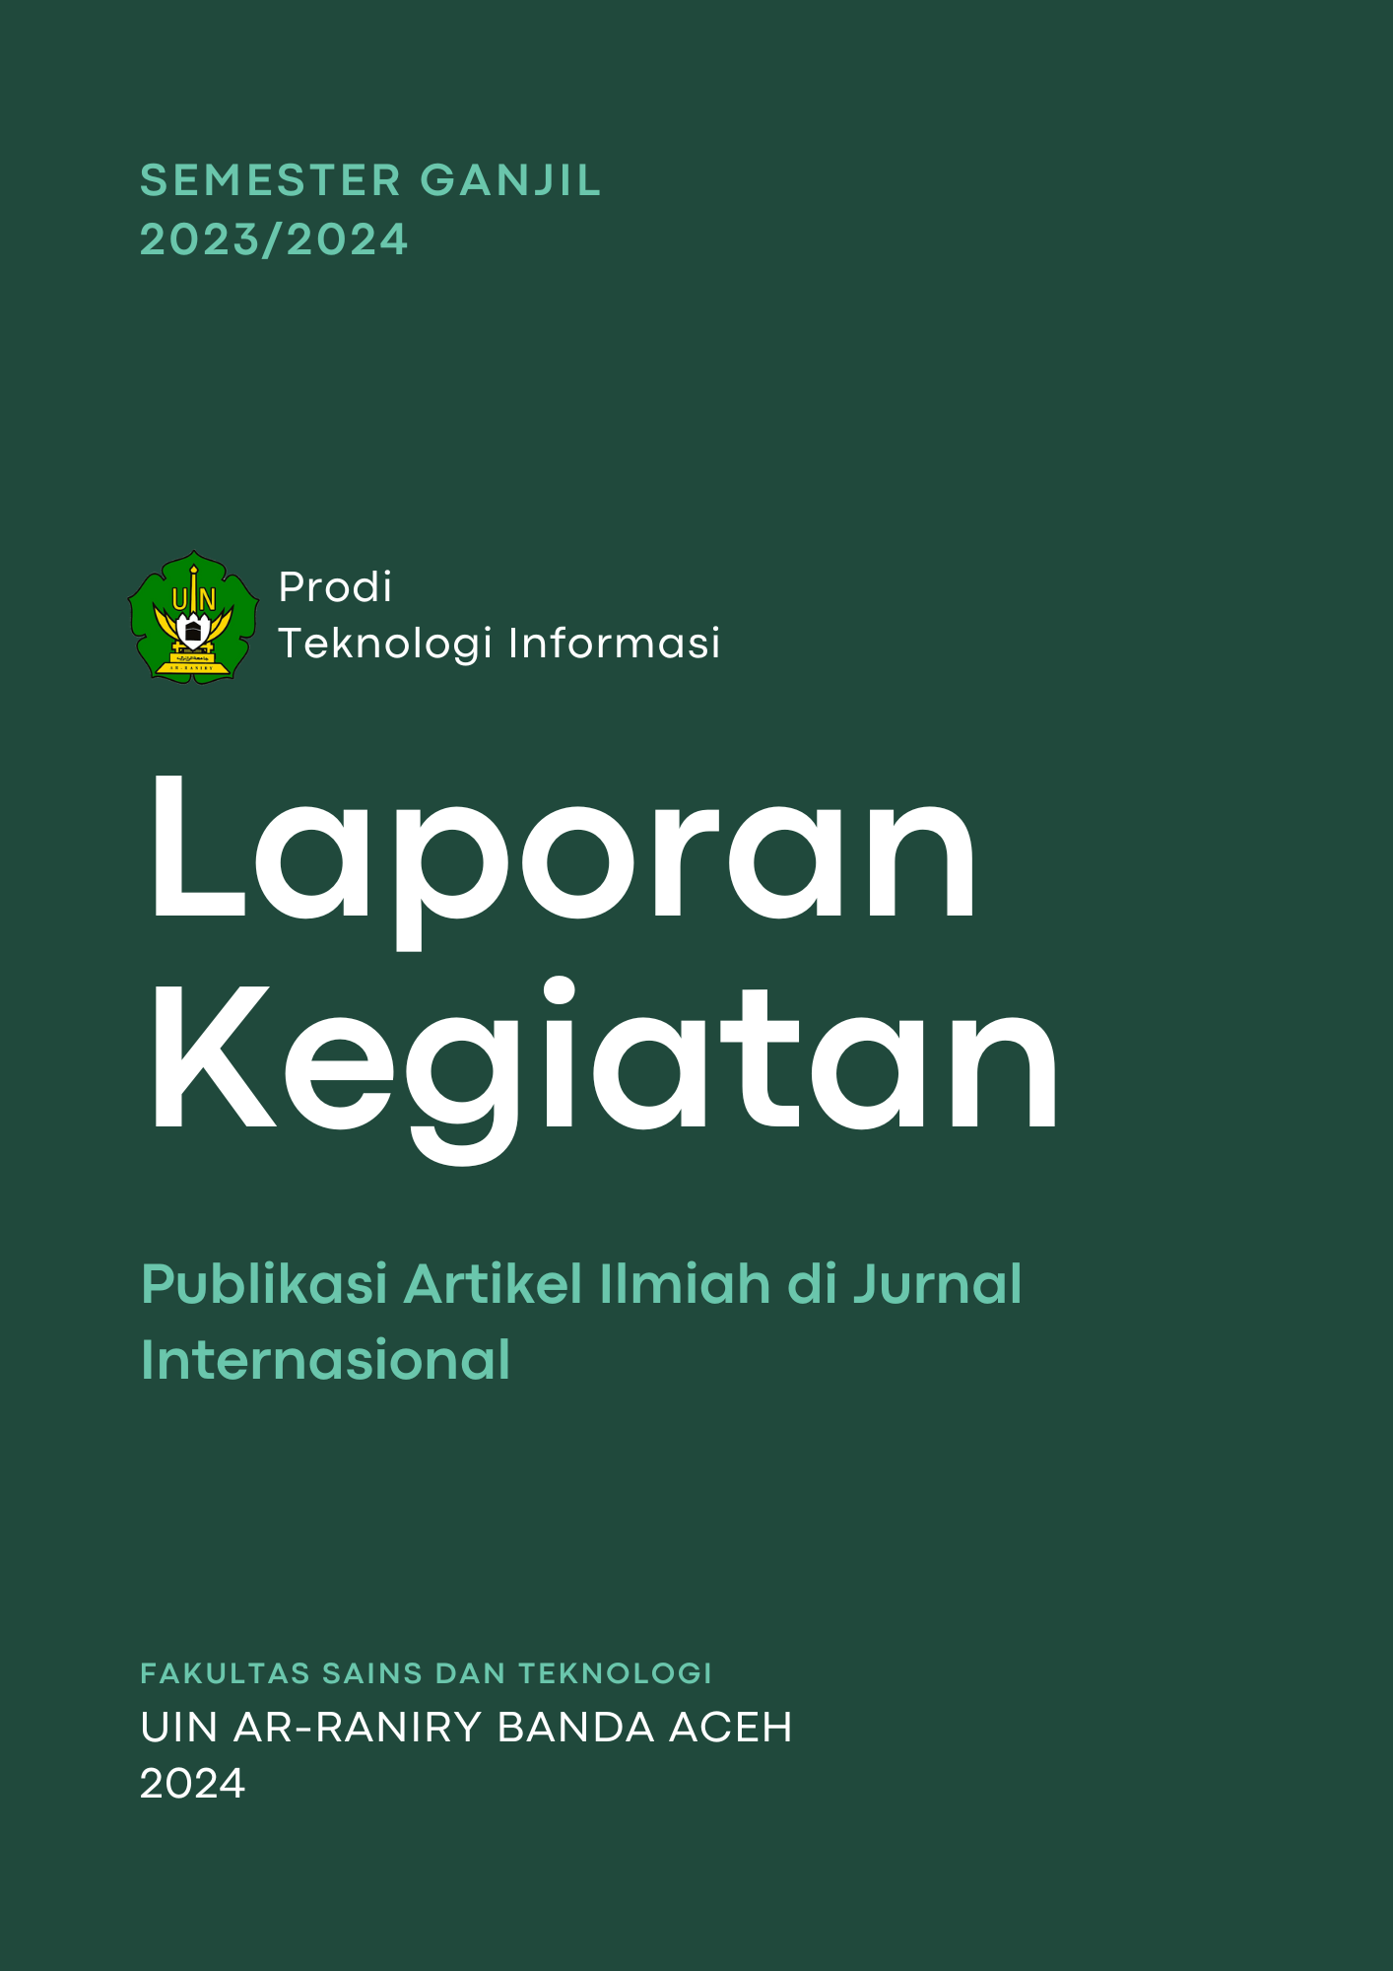

| No. | Jenis Jurnal | Nama Jurnal | Penulis | Judul | Bukti |
| --- | --- | --- | --- | --- | --- |
| (1) | (2) | (3) | (4) | (5) | (6) |
| 1 | Book Chapter | Strategies & Aplications of Islamic Enterpreneurship | Ima Dwitawati | Using the Unified Theory of Acceptance and Use of Technology to Explore the Factors Influencing Muslim Consumers in Purchasing Halal Products | <https://www.igi-global.com/chapter/using-the-unified-theory-of-acceptance-and-use-of-technology-to-explore-the-factors-influencing-muslim-consumers-in-purchasing-halal-products/331155>  <https://drive.google.com/file/d/1Is0_9Vm1IpVAAH-EaKdbXgvZSn3zbohr/view?usp=drive_link> |
| 2. | Internasional Bereputasi | IEEE Xplore | Hendri Ahmadian | Transformer-Based Indonesian Language Model for Emotion Classification and Sentiment Analysis | <https://ieeexplore.ieee.org/document/10442970>  <https://drive.google.com/file/d/1l-W1rsaCVDhX1undH8MT60EruBSjzort/view?usp=drive_link> |

Jumlah Publikasi Internasional Dosen Prodi Teknologi Informasi adalah sebanyak 2 Judul.

Banda Aceh, Januari 2024

Ketua Program Teknologi Informasi



Ima Dwitawati, MBA.

NIP.19821013 201403 2 002=